Slicing Strings
String slicing allows us to get a slice of characters from the string. To get a slice of string we use slicing operator ( [start_index:end_index] ). It's syntax is:
str_name[start_index:end_index]
str_name[start_index:end_index] returns a slice of string starting from index start_index to the end_index. The character at the end_index will not be included in the slice. Consider the following example:
1  2  3  4  5  6  7  8  9  10  11 | >>>  >>> s = "markdown"  >>>  >>>  >>> s[0:3] # get a slice of string starting from index 0 to 3, not including the character at index 3  'mar'  >>>  >>>  >>> s[2:5] # get a slice of string starting from index 2 to 5, not including the character at index 5  'rkd'  >>>
Try it now
If end_index is greater than the length of the string then the slice operator returns a slice of the string starting from start_index to the end of the string.
1  2  3  4 | >>>  >>> s[2:len(s)+200]  'rkdown'  >>>
Try it now
The start_index and end_index are optional. If start_index is not specified then slicing begins at the beginning of the string and if end_index is not specified then it goes on to the end of the string. For example:
1  2  3  4 | >>>  >>> s[:4] # start slicing from the beginning  'mark'  >>>
Try it now
In the above expression, the slicing begins at the beginning of the string, so the above expression is the same as s[0:4].
1  2  3  4 | >>>  >>> s[5:]  'own'  >>>
Try it now
In this case, end_index is omitted as a result, slicing goes on to the end of the string, so s[5:] is the same as s[5:len(s)].
1  2  3  4 | >>>  >>> s[:]  'markdown'  >>>
Try it now
Here we have omitted start_index as well as end_index, thus slicing will start from the beginning and goes on to the end of the string. In other words, s[:] is same as s[0:len(s)]
We can also use a negative index in string slicing.
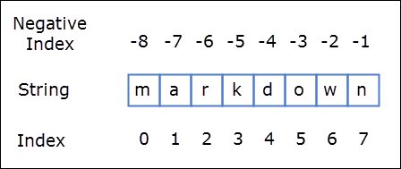
So s[1:-1] will return a slice starting from index 1 to -1, not including the character at index -1.
1  2  3  4 | >>>  >>> s[1:-1]  'arkdow'  >>>

